eCityGov Alliance
Meeting Cancellation Notice

Friday, February 20th, 2026; 10:00am-12:00pm

As required by the Open Public Meetings Act of 1971, Chapter 250, First Ex. Session, you are hereby notified that the February 20, 2026, meeting of the eCityGov Alliance has been cancelled.

The next regularly scheduled session will be held on April 10, 2026.

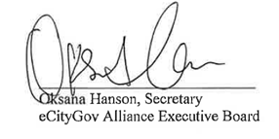
Dated February 17, 2026

